**Plant Disease Detection System for Sustainable Agriculture**

**Problem Statement:**

Develop a Convolutional Neural Network (CNN)-based model adept at detecting and classifying plant diseases through images of leaves from various crops, including apple, cherry, grape, and corn. The model should proficiently discern both healthy and afflicted leaves while accurately predicting the specific type of disease. This innovative system will significantly contribute to precision agriculture by facilitating early detection and effective disease management.

**Defination:**

Lets start with the defination about the basis which is Neural Network (NN). The Neural Network (NN) refers to the neural connection with each other where it is for the mimicking the mind or the brain like the Human beings.

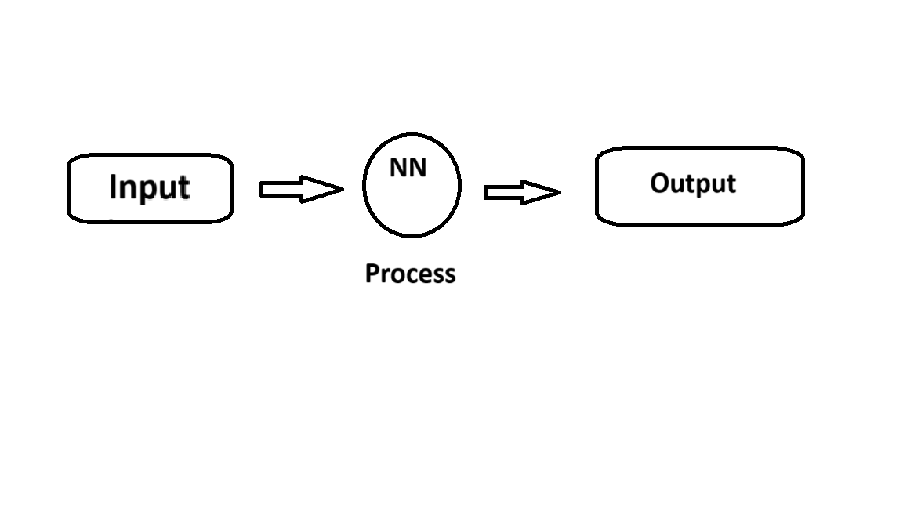

Under the topic Neural Network (NN) there are varrious types but mainly we uses the following types as follows:

1. Artificial Neural Network (ANN)
2. Recurrent Neural Network (RNN)
3. Convolutional Neural Network (CNN)

Now Lets see then one by one,

1. **Artificial Neural Network (ANN)**

The Artificial Neural Network (ANN) is the neural network type where it is for the processing the data like human being mind is process the data for their surrounding as they take it as the inputs.

1. **Recurrent Neural Network (RNN)**

The Recurrent Neural Network (RNN) is the another type of neural network which it is for the detecting and process also understand the emotions like (Anger, love, etc…) like human being does his whole life.

1. **Convolutional Neural Network (CNN)**

The Convolutional Neural Network (CNN) is the third type of the neural type which it Is for the visual specific things like computer vision it is used for visually detect the objects and other stuffs to work with. Like the Human beings are able to see with their eyes and react as the input images(surrounding..).

**PipeLine:**

The pipeline is refers to the step by step guideline for completing the objective and workflow with the problem statement .

The Following is the step by step Pipeline to achieve the problem statement as.

1. **Data Collection and Data Loading**

For playing with the CNN or any NN or using the AI based system we need to have the proper data, so we need to all the data processing and the following shows the graph of data processing .

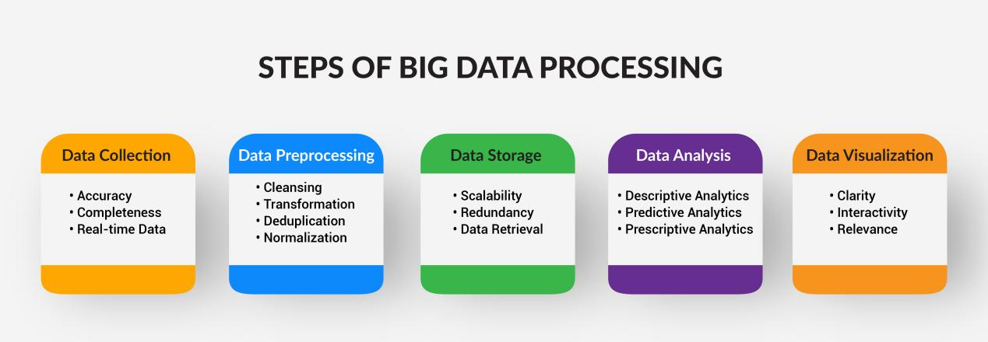

Now in case of uploding the data in the platform we are using the Google colab so to upload we need to have csv for the textual data and for visual we need to drop the file on the colab as it is.

The Data is needed to be cleaned not the Raw or the invalid, or the missing value inside it. And the clean data help for achieving the accurate or precise output.

The Data Loading s the another step to work with in the Google colab using python.

Now lets say about the Data Collection and Data Loading we all are working with the Datasets (The Datasets is the collection of the data’s or the other stuffs like images, texts,etc)

In the Nural Network We are having the Three types of datasets , as follows

1. Train dataset
2. Valid dataset
3. Test dataset

All the datasets have the categories seprately which will be get its own properties like in this project we all are working with the Plant disease and Detection system where inside it there are the data of healthy plants leaves and disease plant leaves and vice versa.

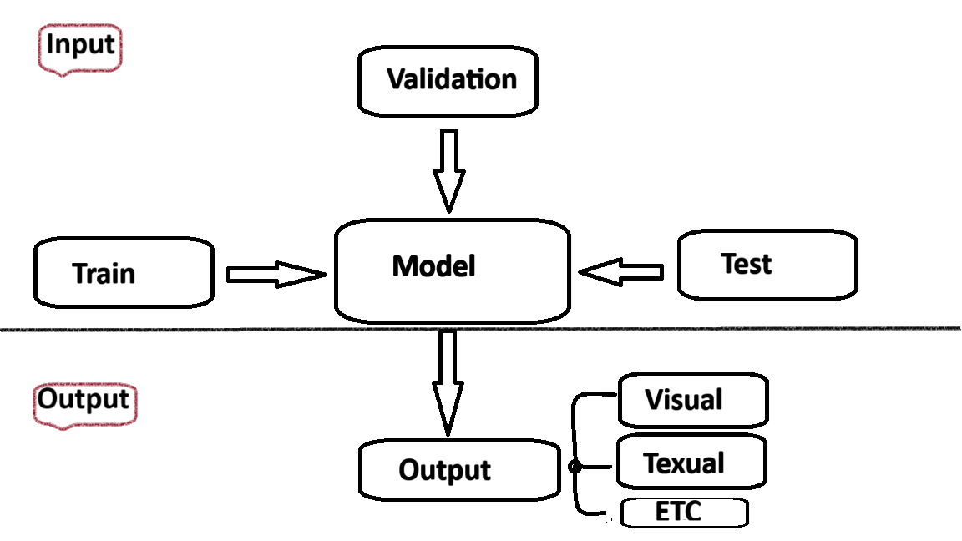

In the Last we will make it happen in web app or android app or an iso app.

1. **Image Processing and Image Augmentation**

Image Processing defines that the image is getting process by the internal model which we will working as the problem statement so this model which is named as CNN or Convolutional Neural Network related to the visual or the vision of the data.

The OpenCV also comes with it.

As we get the image to the database the image (raw image) it will get in any of the following as,

* Blur images
* Changes in image dimensions
* Not proper images
* Cut images, etc…

So in data image cleaning we are using the process named as Image Augmentaion. Where this helps to make it clean in the proper data to use in model for proper and acurate output.

For example:

Fig 1.

Fig 2.

Fig 1 is smaller than fig 2 as we must say that there are changes in dimensions so for that image augmentation comes in process which is that making the all images in one dimensions and help the model to learn form it and provide proper output.

1. **Evaluation / Test**

In finally preview we are going to evaluate the model by giving it the test datasets and get the proper result . and then we will know that how much the model is trained and valid for proper output .

We eventually Evaluate the model by completing all the steps by preparing the proper pipeline for completing the task of our title name “Plant Disease Detection System”..

1. **Platform**

We are using the platform called Google Colab which is for the practice lab for all the programmer and the data analytics, data science enthusiastic students, etc.

The following is the steps to work with google colab .

Step 1. Go to browser

Step 2. Search for Google Colab

Step 3. Click on first link

Step 4. Open it.

Step 5. Log in with your google account.

Step 6. Open the new notebook.

Step 7. Use it.

Thank You.

Note: This is the week one assignment .